Industrial Internship Report on
”Prediction of Agriculture Crop Production in India ”
Prepared by
[KARRA KIRANMAI]

Executive Summary
This report presents the work carried out during the industrial internship on the project "Prediction of Agriculture Crop Production in India." The main objective of this project is to develop a Machine Learning-based prediction system that estimates agricultural crop production using historical agricultural data from different states and regions of India.
Agriculture plays a vital role in the Indian economy, and accurate prediction of crop production is essential for farmers, policymakers, and agricultural organizations. The proposed system analyzes various factors such as State, District, Crop, Season, Area under cultivation, and historical production data to predict future crop production with improved accuracy.
The project was implemented using Python along with libraries such as Pandas, NumPy, Matplotlib, Seaborn, and Scikit-learn for data analysis, visualization, model training, and performance evaluation. Different machine learning models were studied and evaluated to identify the most suitable algorithm for accurate crop production prediction.
This internship provided valuable industrial exposure and practical experience in Data Science, Machine Learning, Data Preprocessing, Model Development, Model Evaluation, GitHub, and Technical Documentation. It enhanced my problem-solving skills, programming knowledge, and understanding of real-world agricultural applications of Artificial Intelligence.
Overall, this project demonstrates how Machine Learning can support smart agriculture by providing reliable crop production predictions, enabling better planning, efficient resource utilization, and informed decision-making for sustainable agricultural development in India.

TABLE OF CONTENTS
1 Preface 3
2 Introduction 4
2.1 About UniConverge Technologies Pvt Ltd 4
2.2 About upskill Campus 8
2.3 Objective 9
2.4 Reference 9
2.5 Glossary 10
3 Problem Statement 11
4 Existing and Proposed solution 12
5 Proposed Design/ Model 13
5.1 High Level Diagram (if applicable) 13
5.2 Low Level Diagram (if applicable) 13
5.3 Interfaces (if applicable) 13
6 Performance Test 14
6.1 Test Plan/ Test Cases 14
6.2 Test Procedure 14
6.3 Performance Outcome 14
7 My learnings 15
8 Future work scope 16

Preface
The Industrial Internship provided an excellent opportunity to gain practical knowledge and hands-on experience in solving real-world problems using Machine Learning. During this six-week internship, I worked on the project "Prediction of Agriculture Crop Production in India." The objective of the project was to develop an intelligent prediction system capable of estimating crop production using historical agricultural data.
This internship helped me understand the complete Machine Learning development lifecycle, including data collection, preprocessing, exploratory data analysis, feature engineering, model training, evaluation, and result visualization. I also learned how to document a project professionally and manage source code using GitHub.
The internship improved my programming skills in Python and enhanced my understanding of Data Science concepts. Working on this project increased my confidence in solving practical industry problems using Artificial Intelligence and Machine Learning.
I sincerely thank UniConverge Technologies Pvt. Ltd. (UCT), upskill Campus, The IoT Academy, my mentors, faculty members, and my college for providing valuable guidance and support throughout the internship.
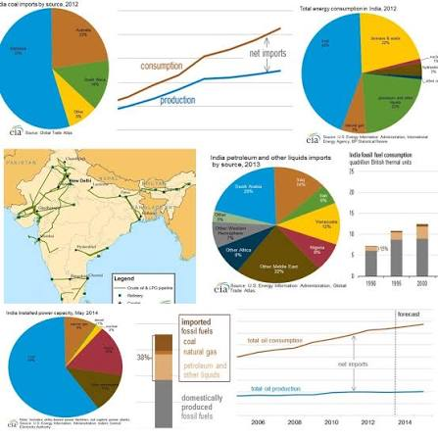

Introduction
Agriculture is one of the most important sectors of the Indian economy, contributing significantly to employment and food security. Predicting crop production helps farmers, agricultural departments, policymakers, and researchers make better decisions regarding cultivation, irrigation, storage, and distribution.
Traditional prediction methods often rely on manual calculations and historical observations, which may not provide accurate results. Machine Learning techniques can analyze large datasets and identify hidden patterns to generate more reliable predictions.
This project focuses on developing a Machine Learning model that predicts agricultural crop production based on historical agricultural data collected from different states and districts of India.

About UniConverge Technologies Pvt Ltd
UniConverge Technologies Pvt. Ltd. (UCT) is an innovative technology company established in 2013. The company provides industrial solutions in IoT, Artificial Intelligence, Cloud Computing, Cyber Security, Machine Learning, Embedded Systems, and Digital Transformation.
UCT focuses on solving real-world industrial challenges through modern technologies. The company also collaborates with educational institutions to provide industry-oriented internship programs that enhance students' practical knowledge and employability.
- i. Agricultural Crop Prediction Platform
The Agricultural Crop Prediction Platform is a Machine Learning-based system developed to predict crop production using historical agricultural data collected from different states and districts of India. The platform helps farmers, researchers, and government organizations make informed decisions regarding crop planning and resource management.
The system is developed using Python for backend processing and Machine Learning implementation. It utilizes libraries such as Pandas, NumPy, Scikit-learn, Matplotlib, and Seaborn for data preprocessing, model training, prediction, and visualization.
- Features
- Predicts crop production using historical agricultural data.
- Supports preprocessing of large agricultural datasets.
- Performs data visualization and exploratory data analysis.
- Uses Machine Learning algorithms for prediction.
- Generates accurate prediction reports.
- Helps farmers improve crop planning and productivity.

- ii. Agricultural Decision Support System
The proposed system acts as an intelligent decision support platform for agriculture.
It provides users with:
- Accurate crop production prediction.
- Historical data analysis.
- Easy visualization of agricultural trends.
- Better planning for cultivation and harvesting.
- Efficient utilization of agricultural resources.
- Reliable prediction results for decision-making.
The system is scalable and can be enhanced by integrating real-time weather and soil information.

- iii. Smart Agriculture Solution
The project provides a Smart Agriculture solution by combining historical agricultural data with Machine Learning techniques.
It can be used for:
- Crop production prediction.
- Agricultural data analysis.
- Yield estimation.
- Crop planning.
- Government policy support.
- Farmer decision support.
- Sustainable agriculture development.
The system helps reduce uncertainty in crop production and supports data-driven farming practices.

- iv. Predictive Crop Production Analysis
The Predictive Crop Production Analysis module applies Machine Learning algorithms to estimate future crop production based on historical agricultural records.
The system analyzes multiple parameters such as:
- State
- District
- Crop
- Season
- Cultivated Area
- Historical Production Data
Using these inputs, the model predicts future crop production with improved accuracy. This enables farmers and agricultural organizations to make better decisions regarding cultivation, resource allocation, and food production planning.

About upskill Campus (USC)
upskill Campus along with The IoT Academy and in association with Uniconverge technologies has facilitated the smooth execution of the complete internship process.
USC is a career development platform that delivers personalized executive coaching in a more affordable, scalable and measurable way.




Seeing need of upskilling in self paced manner along-with additional support services e.g. Internship, projects, interaction with Industry experts, Career growth Services
https://www.upskillcampus.com/
upSkill Campus aiming to upskill 1 million learners in next 5 year

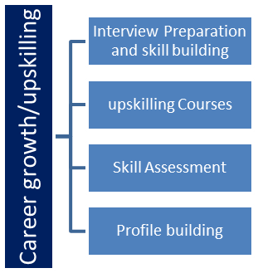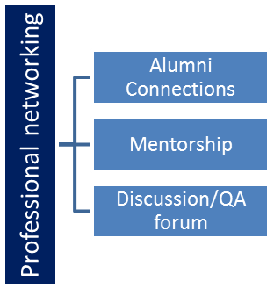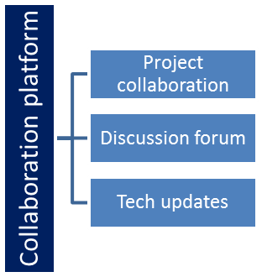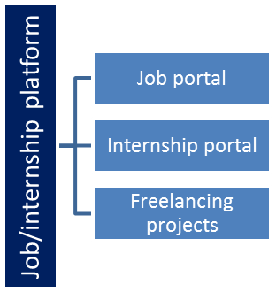

The IoT Academy
The IoT academy is EdTech Division of UCT that is running long executive certification programs in collaboration with EICT Academy, IITK, IITR and IITG in multiple domains.

Objectives of this Internship program
The main objectives of this project are:
• Predict agricultural crop production accurately using Machine Learning.
• Analyze historical agricultural datasets.
• Build a data-driven prediction model.
• Help farmers and agricultural authorities make better decisions.
• Improve productivity using AI-based prediction techniques.
• Learn practical implementation of Machine Learning algorithms.

Reference
[1] https://www.kaggle.com
[2] https://scikit-learn.org
[3] https://pandas.pydata.org
[4] https://numpy.org
[5] https://matplotlib.org
[6] https://github.com
[7] https://www.upskillcampus.com

Glossary
Terms | Acronym
AI | Artificial Intelligence
ML | Machine Learning
CSV | Comma Separated Values
EDA | Exploratory Data Analysis
Dataset | Collection of agricultural records

Problem Statement
Agricultural production depends on several factors such as crop type, state, district, season, cultivated area, climate, and historical production records. Farmers often face uncertainty in estimating future crop production, leading to inefficient planning and resource utilization.
The objective of this project is to develop a Machine Learning model that predicts agricultural crop production in India using historical agricultural data. The system should provide accurate predictions that support farmers, researchers, and government agencies in making informed agricultural decisions.

Existing and Proposed solution

Existing Solution

Limitations

• Low prediction accuracy

• Time-consuming analysis

• Manual decision-making

• Limited data utilization

Proposed Solution

The proposed system uses Machine Learning algorithms to analyze historical agricultural data and predict crop production accurately.

The solution performs:

• Data preprocessing

• Missing value handling

• Feature engineering

• Model training

• Prediction

• Performance evaluation

Advantages

• Faster processing

• Data-driven decision making

• Easy scalability

• Better agricultural planning

Code submission (Github link): https://github.com/kiranmaikarra/prediction-of-agriculture-crop-production-india

Report submission (Github link) :
https://github.com/kiranmai286/test_code.git

Proposed Design/ Model

Given more details about design flow of your solution. This is applicable for all domains. DS/ML Students can cover it after they have their algorithm implementation. There is always a start, intermediate stages and then final outcome.

High Level Diagram (if applicable)

Figure 1: HIGH LEVEL DIAGRAM OF THE SYSTEM

Low Level Diagram (if applicable)

Interfaces (if applicable)
Update with Block Diagrams, Data flow, protocols, FLOW Charts, State Machines, Memory Buffer Management.

Performance Test

This is very important part and defines why this work is meant of Real industries, instead of being just academic project.
Here we need to first find the constraints.
How those constraints were taken care in your design?
What were test results around those constraints?
Constraints can be e.g. memory, MIPS (speed, operations per second), accuracy, durability, power consumption etc.
In case you could not test them, but still you should mention how identified constraints can impact your design, and what are recommendations to handle them.

Test Plan/ Test Cases

Test Procedure

Performance Outcome

My learnings

You should provide summary of your overall learning and how it would help you in your career growth.

Future work scope

You can put some ideas that you could not work due to time limitation but can be taken in future.

